DENVILLE SCHOOLS MANDATORY HEALTH SCREENINGS OPT OUT FORM
SCHOOL YEAR: 2020-2021
Dear Parent/Guardian,
Throughout a typical school year, multiple health screenings required by the state of New Jersey are conducted. As per, N.J.A.C. 6A:16-2.2(g)3 and N.J.A.C. 6A:16-2.3(b)3ii mandated health screenings include height, weight, blood pressure, hearing, vision, and scoliosis.
The grades in which these screening must be carried out are as follows:
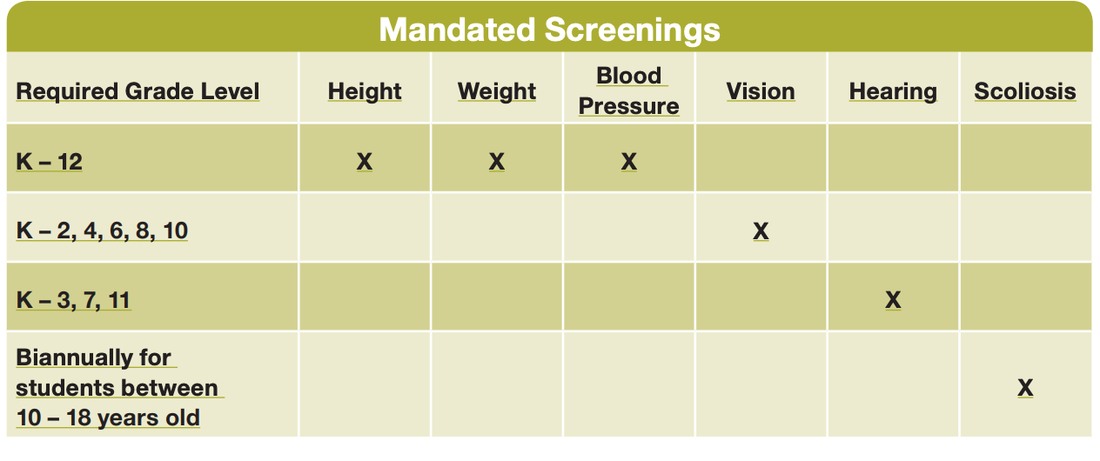
Please note that many of these screenings are typically a part of the physical for sports, entry to school or annual well visits. Health screening information provided on these documents that were submitted this year will satisfy the mandatory requirements and you do not need to reply if you have already submitted a physical. Some school-based screenings may have already been completed, however you may opt-out of remaining required screenings by indicating this and signing below.
You may submit a physical performed by your child’s doctor using the attached Universal Health Form in lieu of a school based screening. Please note, school nurse screenings are not physicals.
This form should be completed and returned to your school nurse by Friday May 21, 2021. A failure to complete and return this form by this date will be considered an OPT OUT OPTION.
Student Name: _______________________________ Grade: ___ Teacher: ___________________
(check one)
___ I choose to opt my child out of health screenings for the 2020-2021 school year.
___ I choose to have my child’s physician perform a physical exam instead of the school screening.
___ I choose to have my student screened as mandated for the 2020-2021 school year by the school nurse..(If your student is virtual, contact the nurse to schedule an appointment)
*If your student is a remote learner and you chose not to opt out of the mandatory screenings, please contact your school nurse to make an appointment for the screenings to be conducted.
School Nurse: ______________________________ Telephone: ( ) _____________________
Parent/Guardian ___________________________________________ Date: ________________

